Anti-Litter Social Media Posts
Thank you for helping get the word out about litter. Below are some suggested social media messages, but feel free to craft your own!

General Anti-Litter
  - Facebook
(using one of the Luke Comb’s PSAs)
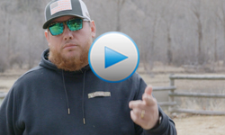
Join us, NCDOT and country music star Luke Combs in keeping N.C. beautiful!
Trash belongs in a 🗑️, not in our roadways so always:
- Secure your load
- Throw trash away in appropriate containers
- Recycle when possible

➡️ Learn how you can help at ncdot.gov

  - Twitter
(using same PSA as above)
.@Luke Combs knows what’s up. ⭐ It takes everyone to keep N.C. green and clean!

➡️ Learn how you can help at ncdot.gov

  - Facebook
The 2021 Spring Litter Sweep is just around the corner! Join us April 10–24 as we get outside and help keep our state clean! We can’t do this without you.
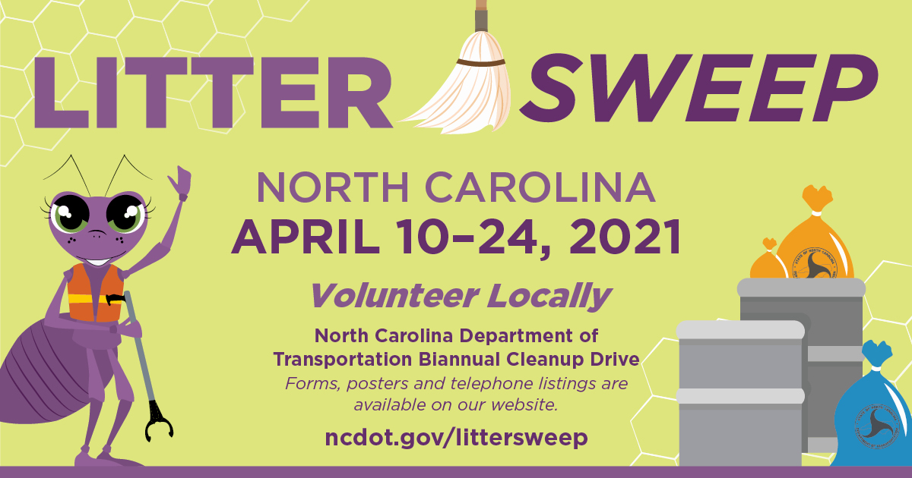

➡️ Join the team: ncdot.gov/littersweep

  - Twitter
(using same image as Facebook)
It’s spring cleaning 🗓️ and our state needs you. Join us April 10–24 for #LitterSweepNC 🧹 and help keep N.C. beautiful!

➡️ Make a difference: ncdot.gov/littersweep

Swat-A-Litterbug
  - Facebook
Help stop litter at its source! If you see someone littering, report them through the new Swat-A-Litterbug app. 📱 We need everyone’s help to keep North Carolina beautiful and clean!

➡️ Get started: ncdot.gov/litter

  - Twitter
🐜 See a bug, swat a bug!
👀 Spy someone littering? Easily report them with the Swat-A-Litterbug app.

➡️ Get started: ncdot.gov/litter

