CHECK APPROPRIATE BOX:
Proposed Temporary Rule [G.S. 150B-21.1(a3)]
Proposed Temporary Rule simultaneously adopted as an emergency rule [G.S. 150B-21.1A(a)]

 | 1. Rule-Making Agency: NC Division of Motor Vehicles
2. Proposed Action -- Mark the appropriate box(es) and list rule citation(s) beside proposed action:

ADOPTION: 19A NCAC 03K .0103 REVIEW OF DENIAL FOR IGNITION INTERLOCK SYSTEM

 | AMENDMENT:
 | REPEAL:
3. Public Hearing:

Date: Tuesday, March 15, 2022
Time: 10:00 am
Location: GoTo Meeting https://attendee.gotowebinar.com/register/2069434136979734797 After registering, you will receive a confirmation email containing information about joining the webinar. Teleconference 1-415-930-5321, Access Code: 348-889-276
4. Reason for agency adopting rule(s) under temporary action:

A serious and unforeseen threat to the public health, safety or welfare.
The effective date of a recent act of the General Assembly or of the U.S. Congress.
Cite: SL 2021-182
Effective date: November 19, 2021
A recent change in federal or state budgetary policy.
Effective date of change:
A recent federal regulation.
Cite:
Effective date:
A recent court order.
Cite order:
Other:

Explain: Session Law 2021-182 Section 1.(e) Article 3 of Chapter 20 of the General Statutes was amended by adding a new section to read: "§ 20-179.5. (e) Reduction of Costs. – A vendor who receives a waiver under subsection (b) of this section that complies with the requirements of subsections (c) and (d) of this section shall install the ignition interlock system in accordance with both of the following terms: (1) The applicant shall not be required to pay for installation or removal of the ignition interlock system or systems. (2) The applicant shall receive a fifty percent (50%) discount on the monthly service rate charged to persons who are not granted a waiver under this section.
Session Law 2021-182 Section 1.(f) states that the Division of Motor Vehicles shall adopt temporary rules to implement the provisions of G.S. 20-179.5, as enacted by subsection (e) of this section. Temporary rules adopted in accordance with this subsection shall remain in effect until permanent rules that replace the temporary rules become effective. The agency is proposing to adopt the proposed temporary rule 19A NCAC 03K .0103 Review of Denial for Ignition Interlock System to comply with the Session Law.

5. Comments from the public shall be directed to:
Name: Hannah Jernigan
Address: 1501 MSC, Raleigh, NC 27699-1501
Phone (optional):
Fax (optional):
E-Mail (optional): Rulemaking@ncdot.gov

 | 6. Comment Period Starts:  March 1, 2022 | Comment Period Ends:  March 30, 2022
 | 7. Rule-making Coordinator:  Name: Hannah Jernigan  Phone: 919-707-2821  E-Mail: Rulemaking@ncdot.gov | 8. Signature of Agency Head* or Rule-making Coordinator:  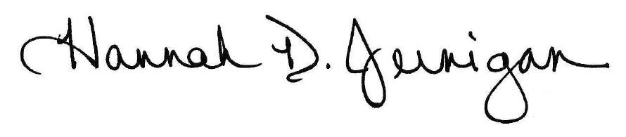  ____________________________________________________  Typed Name: Hannah Jernigan  Title: APA Program Manager and DMV Rule-making Coordinator  *If this function has been delegated (reassigned) pursuant to  G.S. 143B-10(a), submit a copy of the delegation with this form.
Agency contact, if any:
Name: Hannah Jernigan
Phone: 919-707-2821
E-mail: Rulemaking@ncdot.gov

